EXPERIMENT II

AIM:
To develop a student dataset using NumPy and Pandas, store it in an SQLite database, and perform basic data analysis and visualization to derive meaningful insights.

ALGORITHM:
• Import the required libraries such as NumPy, Pandas, SQLite3, and Matplotlib.
• Create a student dataset with the required attributes using NumPy and Pandas.
• Store the dataset in an SQLite database.
• Retrieve the stored data from the database for analysis.
• Perform basic statistical analysis on the retrieved dataset.
• Generate suitable visualizations to represent the data graphically.
• Interpret the patterns and trends obtained from the analysis.
• Display the final results and verify the correctness of the output.

PROGRAM:
# ============================================================
# EXPERIMENT 2: MULTI-FORMAT DATA INPUT/OUTPUT & DATAFRAME OPERATIONS
# Dataset: playbyplay.csv (NBA Play-by-Play Dataset)
# ============================================================

import pandas as pd
import sqlite3

# -------------------------------
# Create & Export Initial Datasets
# -------------------------------
df_full = pd.read_csv('pbp2026.csv')
df = df_full.sample(300, random_state=42).reset_index(drop=True)

df.to_csv('playbyplay.csv', index=False)
df.to_excel('playbyplay.xlsx', index=False)
df.to_csv('playbyplay.txt', sep='\t', index=False)

print('Files Created Successfully!')

# -------------------------------
# Program 1 - Import CSV File
# -------------------------------
csv_df = pd.read_csv('playbyplay.csv')

print('CSV Dataset')
print(csv_df.head())

# -------------------------------
# Program 2 - First Five Records
# -------------------------------
print('First Five Records')
print(csv_df.head())

# -------------------------------
# Program 3 - Dataset Information
# -------------------------------
print('Dataset Information')
print(csv_df.info())

# -------------------------------
# Program 4 - Statistical Summary
# -------------------------------
print('Statistical Summary')
print(csv_df.describe())

# -------------------------------
# Program 5 - Import Excel File
# -------------------------------
excel_df = pd.read_excel('playbyplay.xlsx')

print('Excel Dataset')
print(excel_df.head())

# -------------------------------
# Program 6 - Import SQL Data
# -------------------------------
conn = sqlite3.connect('playbyplay.db')

df.to_sql('PlayByPlayTable', conn, if_exists='replace', index=False)

sql_df = pd.read_sql('SELECT * FROM PlayByPlayTable', conn)

print('SQL Dataset')
print(sql_df.head())

conn.close()

# -------------------------------
# Program 7 - Import Data from Web
# -------------------------------
url = 'https://raw.githubusercontent.com/mwaskom/seaborn-data/master/iris.csv'

web_df = pd.read_csv(url)

print('Web URL Dataset')
print(web_df.head())

# -------------------------------
# Program 8 - Export to CSV
# -------------------------------
csv_df.to_csv('play_output.csv', index=False)
print('CSV File Exported')

# -------------------------------
# Program 9 - Export to Excel
# -------------------------------
csv_df.to_excel('play_output.xlsx', index=False)
print('Excel File Exported')

# -------------------------------
# Program 10 - Export to JSON
# -------------------------------
csv_df.to_json('play_output.json')
print('JSON File Exported')

# -------------------------------
# Additional Data Operations
# -------------------------------
print('Series')
print(csv_df['player'].head())

print('Made Shots')
print(csv_df[csv_df['result'] == 'Made'])

print('Shots Beyond 25 ft')
print(csv_df[csv_df['dist'] > 25])

print('Made Shots Beyond 25 ft')
print(csv_df[(csv_df['result'] == 'Made') & (csv_df['dist'] > 25)])

print('Selected Columns')
print(csv_df[['player', 'team', 'result']])

print('Missing Values Before Cleaning')
print(csv_df.isnull().sum())

csv_df['x'] = csv_df['x'].fillna(csv_df['x'].mean())
csv_df['y'] = csv_df['y'].fillna(csv_df['y'].mean())
csv_df['dist'] = csv_df['dist'].fillna(csv_df['dist'].mean())
csv_df['team'] = csv_df['team'].fillna(csv_df['team'].mode()[0])
csv_df['player'] = csv_df['player'].fillna(csv_df['player'].mode()[0])

print('Missing Values After Cleaning')
print(csv_df.isnull().sum())

csv_df.to_csv('playbyplay_cleaned.csv', index=False)

print('Final cleaned dataset exported as playbyplay_cleaned.csv')

OUTPUT:
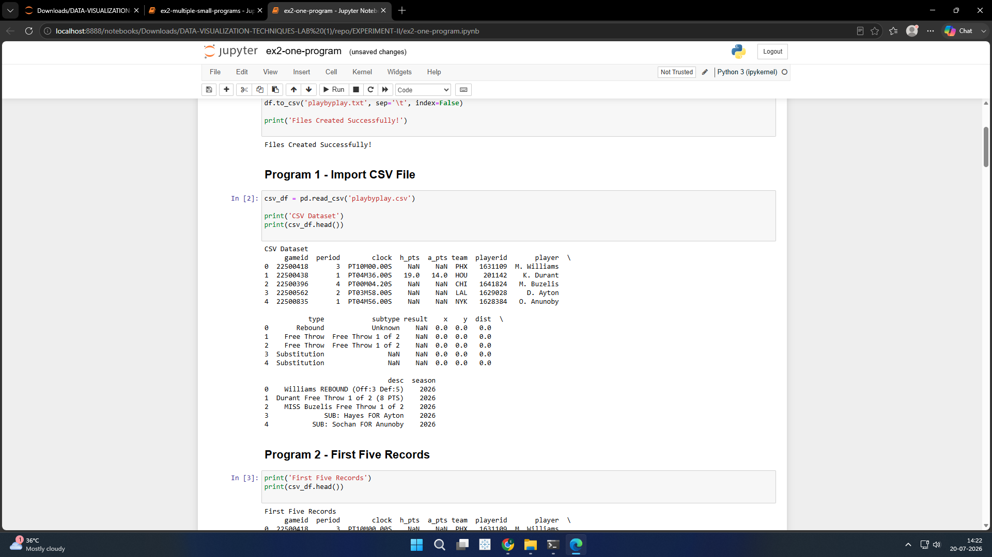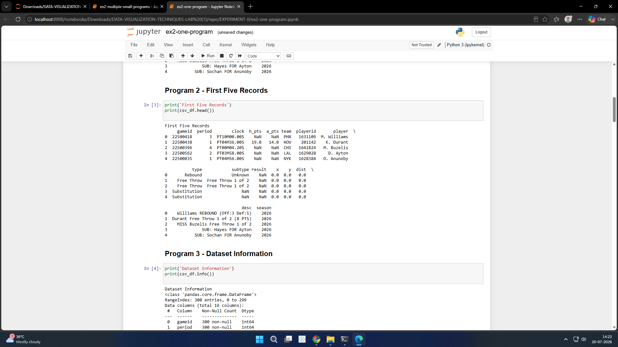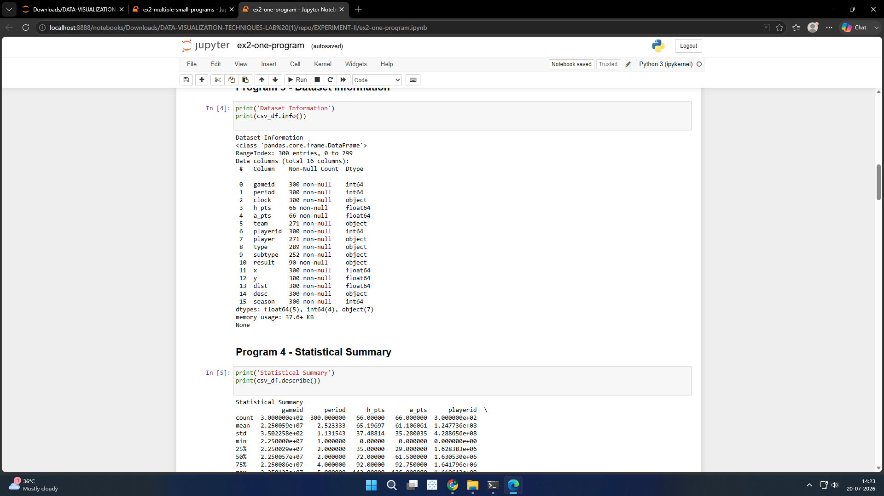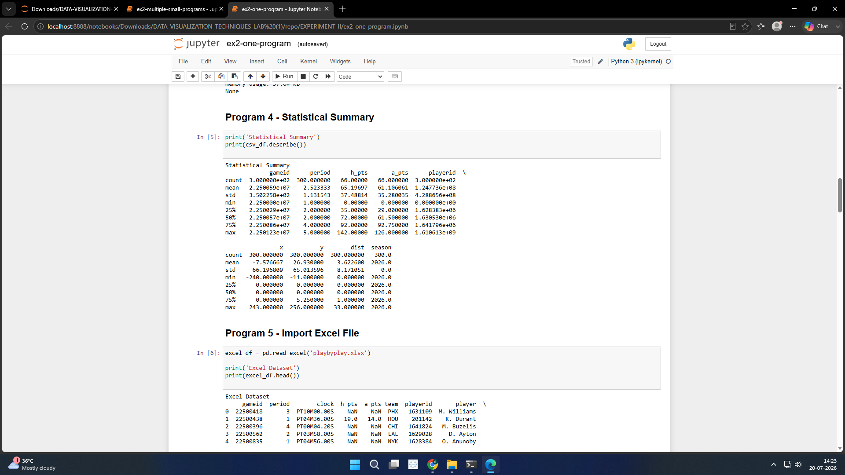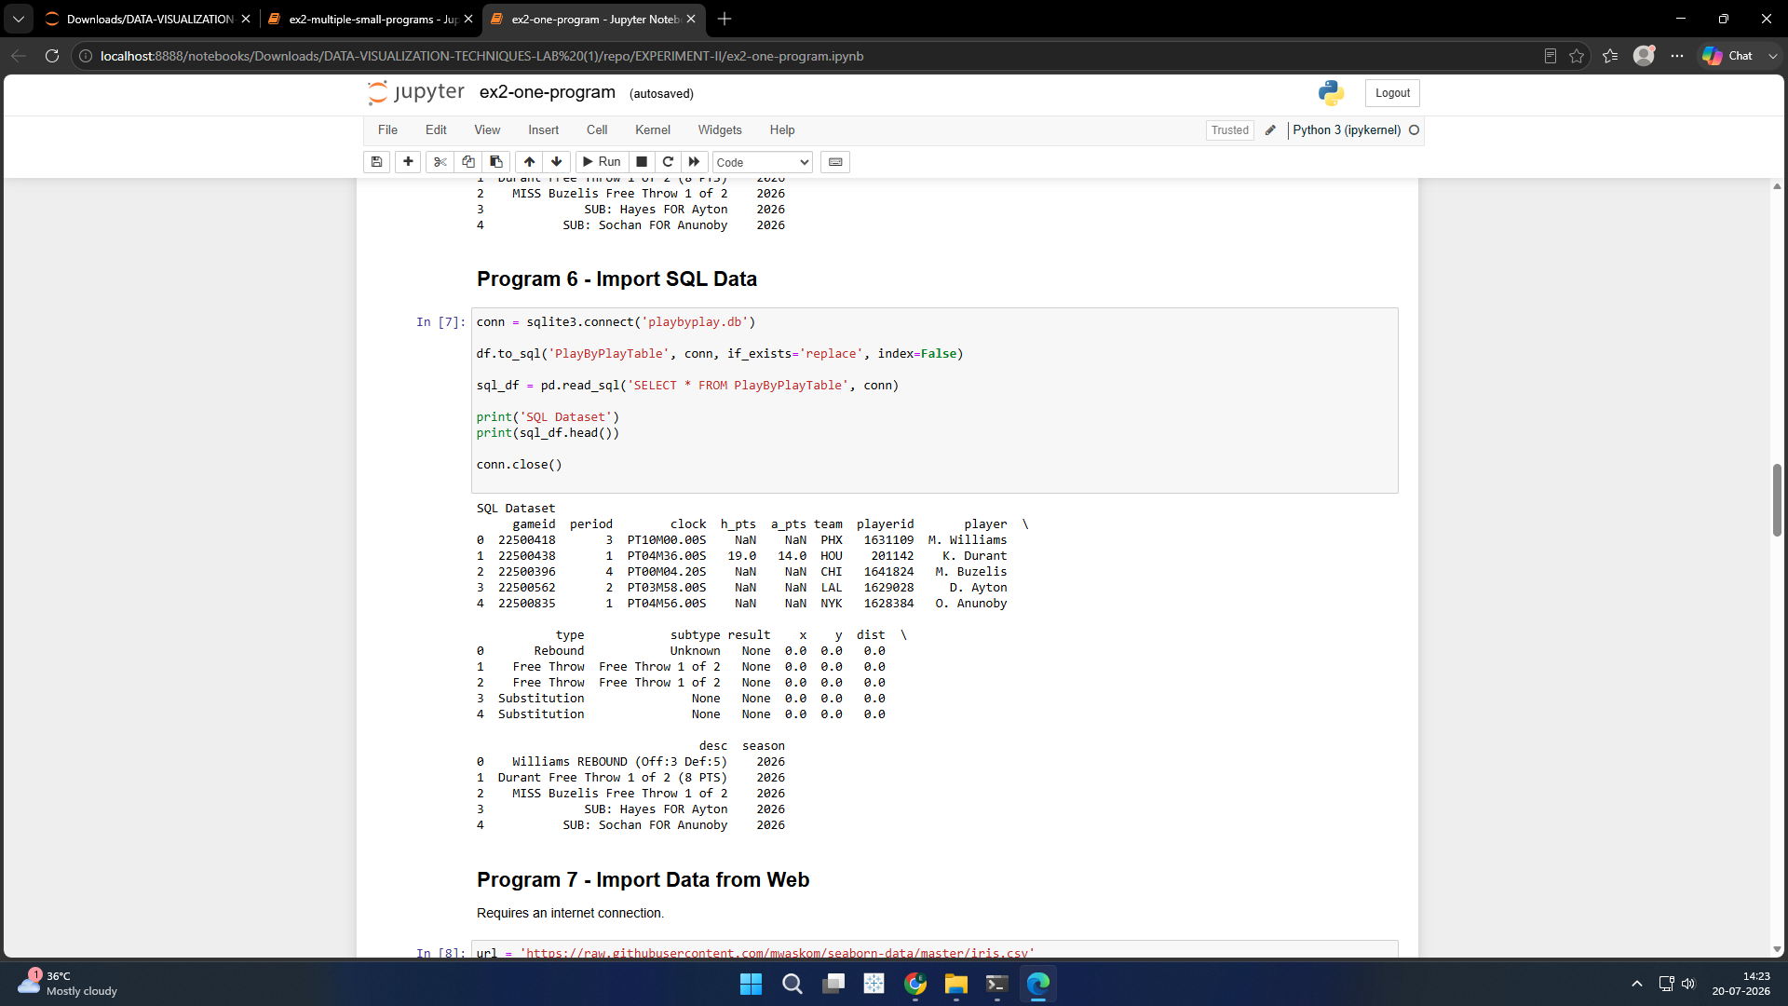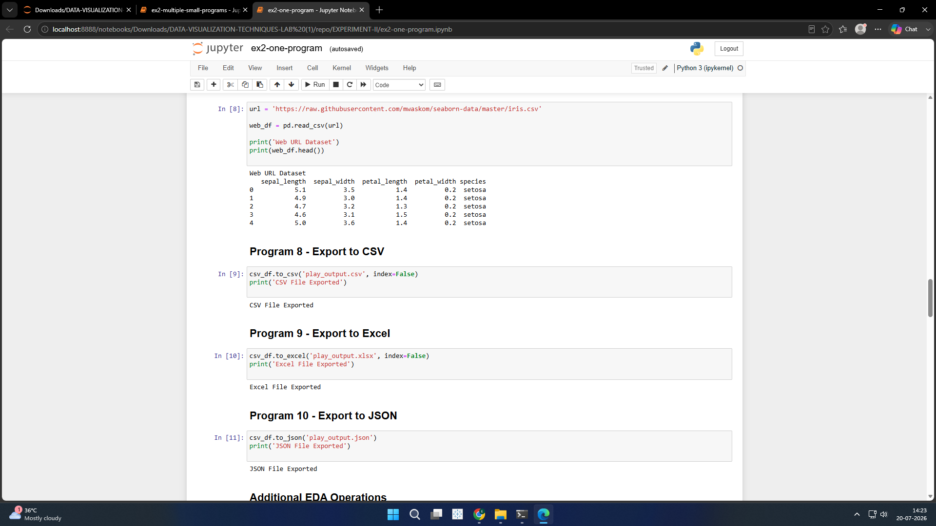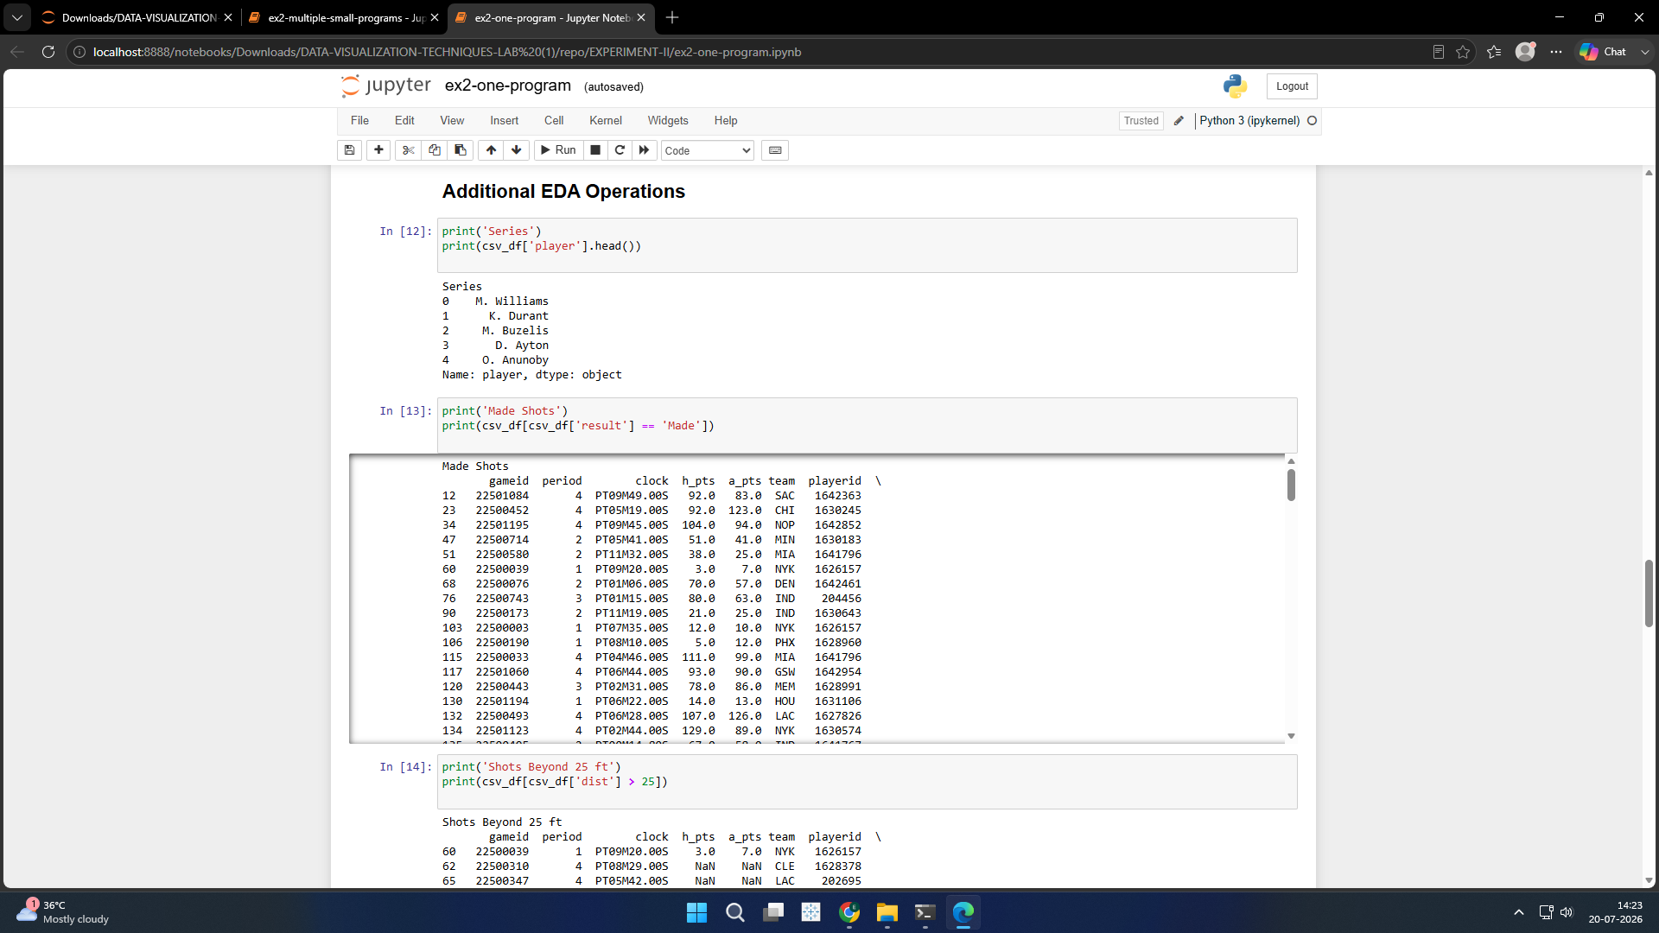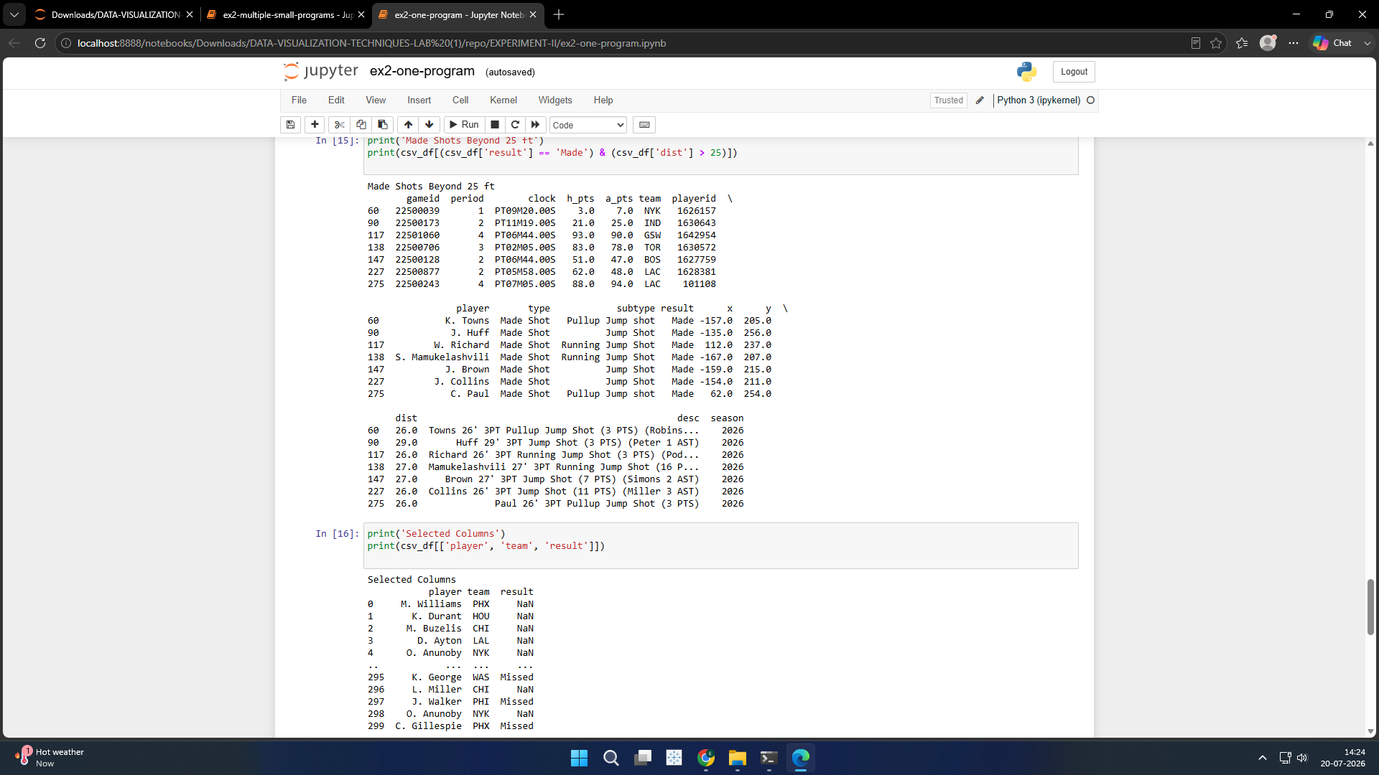

RESULT:
The student dataset was successfully created, stored in the SQLite database, retrieved for analysis, and visualized using appropriate graphs, enabling effective interpretation of the data.

